**PROJECT TITLE** : **GARAGE MANAGEMENT SYSTEM**

**College Name** : Tiruppur Kumaran College For Women.

**College Code** : bru3j

**Team Id** : NM2025TMID28375

**Team Members :** 4

Team Leader : Prathiuksha.J

Email : prathijmvsha@gmail.com

Team member1: Rahini.P

Email : rahiniragi7@gmail.com

Team member2 : Sanjaya Shree.A

Email : aarumugams597@gmail.com

Team member3: Dharani.C

Email : dhrndeepika@gmail.com

Introduction

Project overview

The Garage Management System is a valuable tool for automotive repair facilities, helping them deliver top-notch service, increase operational efficiency, and build lasting customer relationships. With its user-friendly interface and powerful features, GMS empowers garages to thrive in a competitive market while ensuring a seamless and satisfying experience for both customers and staff.

The Garage Management System project aims to:

* Streamline garage operations
* Enhance customer experience
* Automate workflows
* Improve efficiency and productivity
* Provide real-time insights and reporting.

Main objective:

* The main objective of a Garage Management System project is to Improve Operational Efficiency and Enhance Customer Satisfaction by automating and streamlining garage operations.
* Automate and streamline garage operations like scheduling, inventory management, and workflow processes.
* Provide personalized service, real-time updates, and improve communication with customers.

**DEVELOPMENT PHASE**

Creating Developer Account:

By using the URL -  <https://developer.salesforce.com/signup>

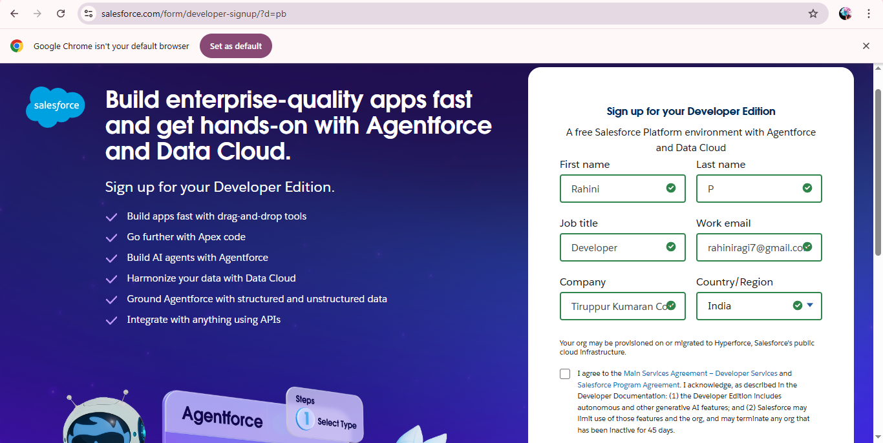

* Created Objects: Customer Details,Appointment, Service Records,Billing Details and Feedback objects.

. 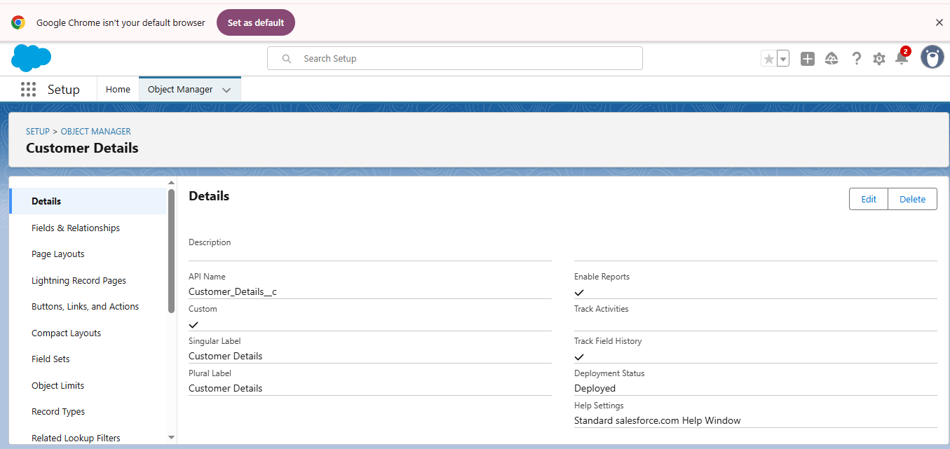

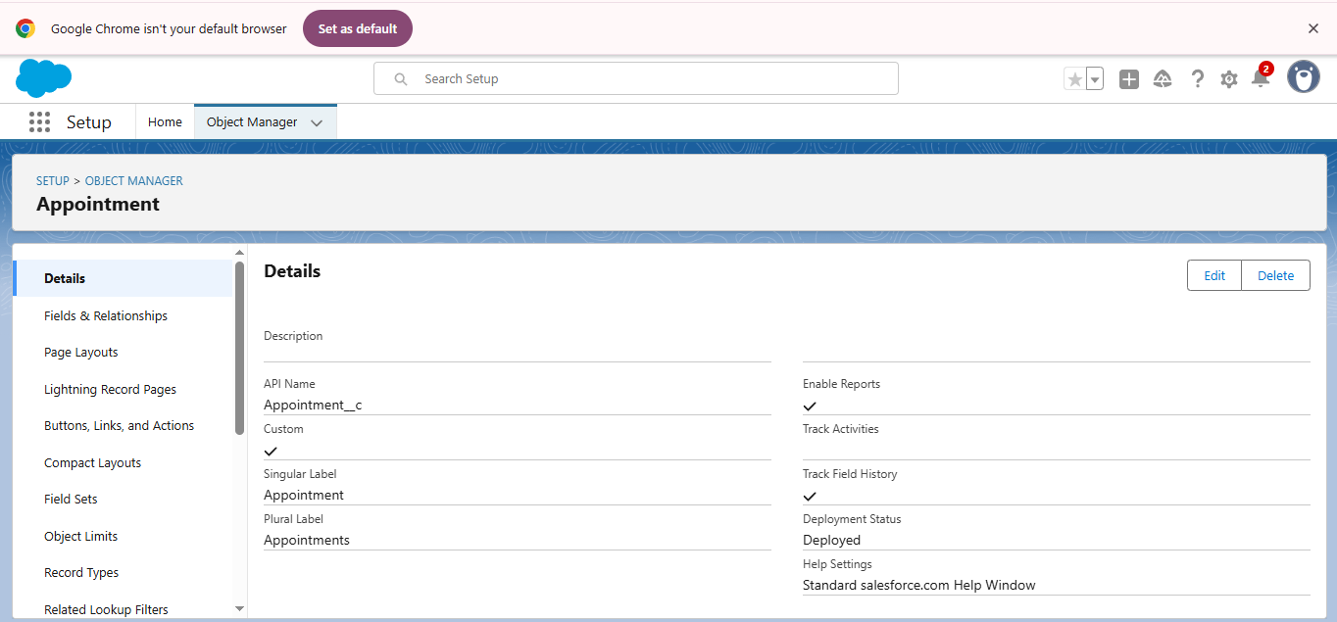

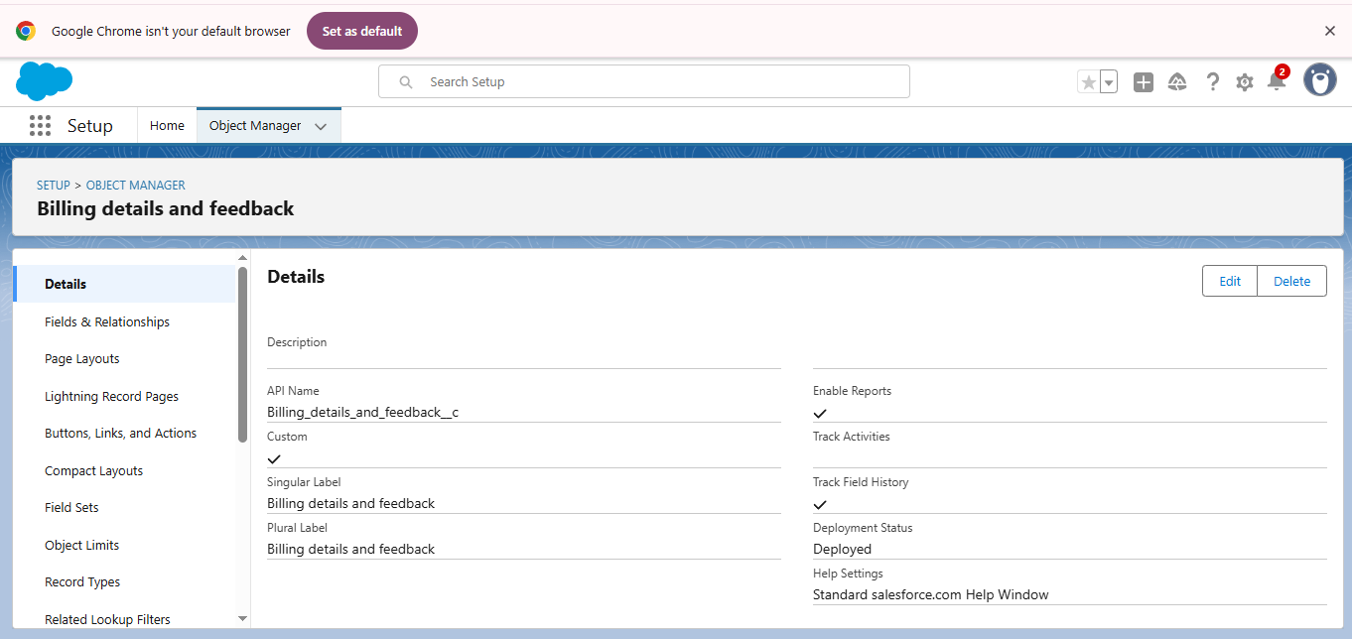

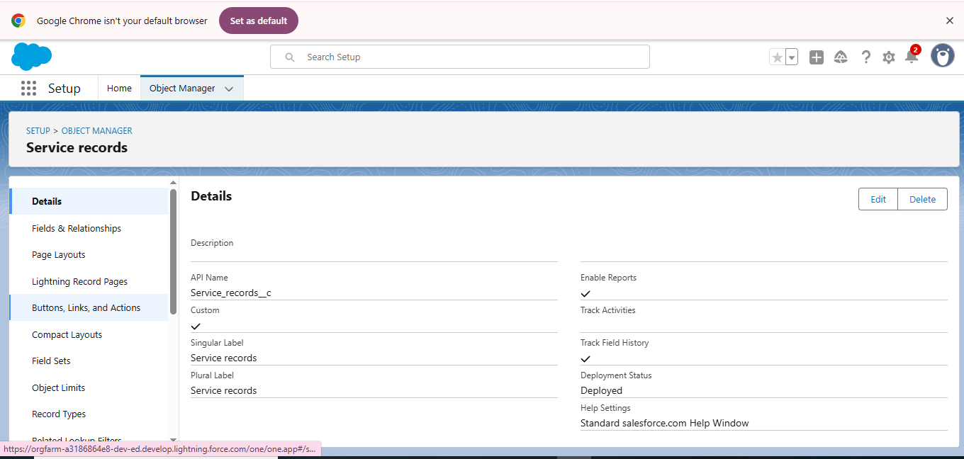

TABS

* tab is like a user interface that is used to build records for objects and to view the records in the objects.

### C:\Users\ELCOT\Pictures\Screenshots\10tab.png

### Create a Lightning App

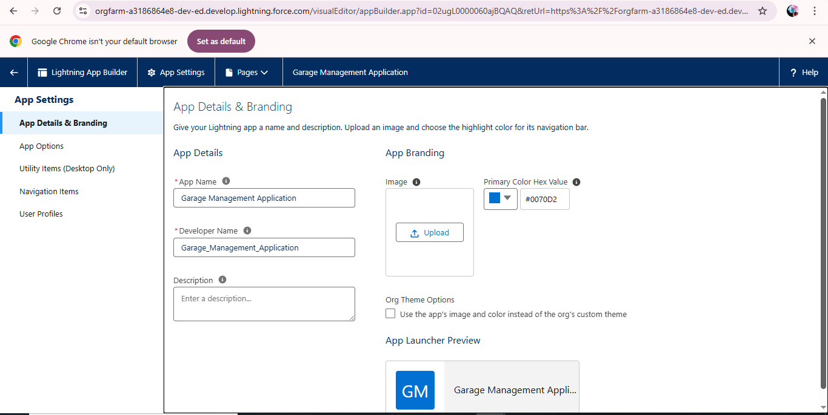

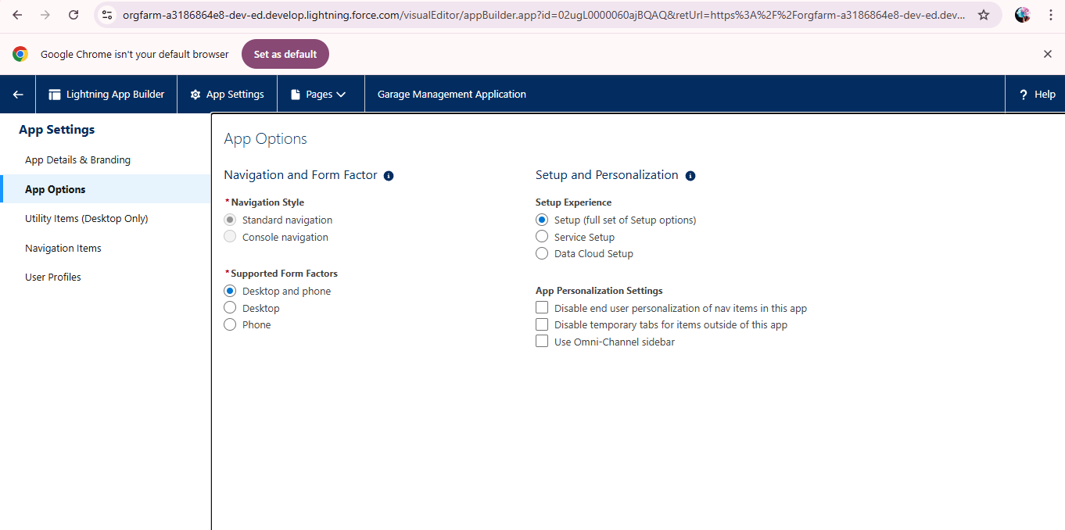

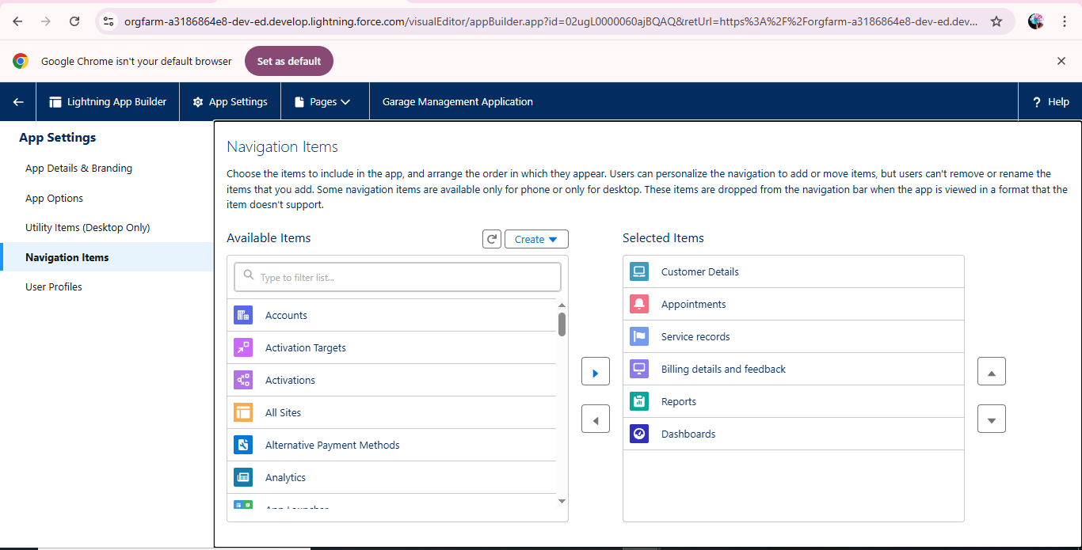

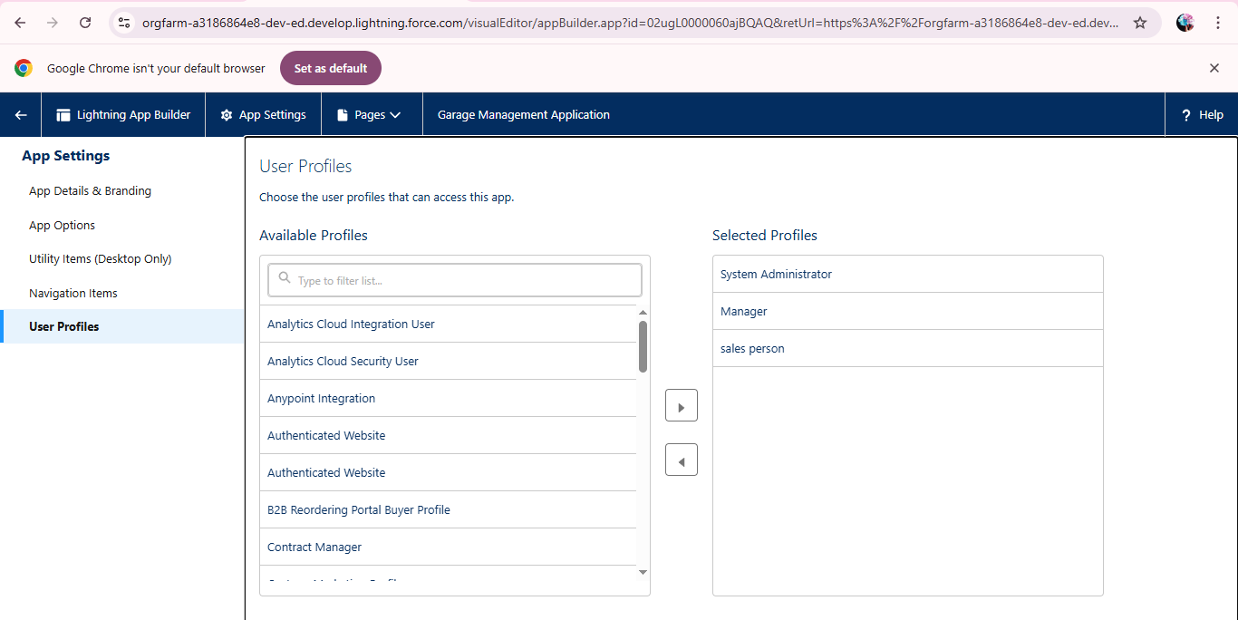

* Created Fields and Relatioships for objects:

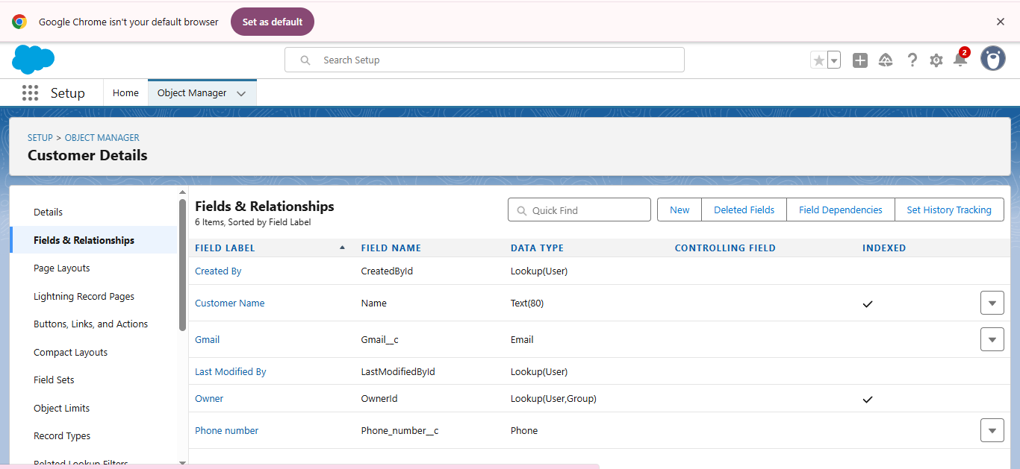

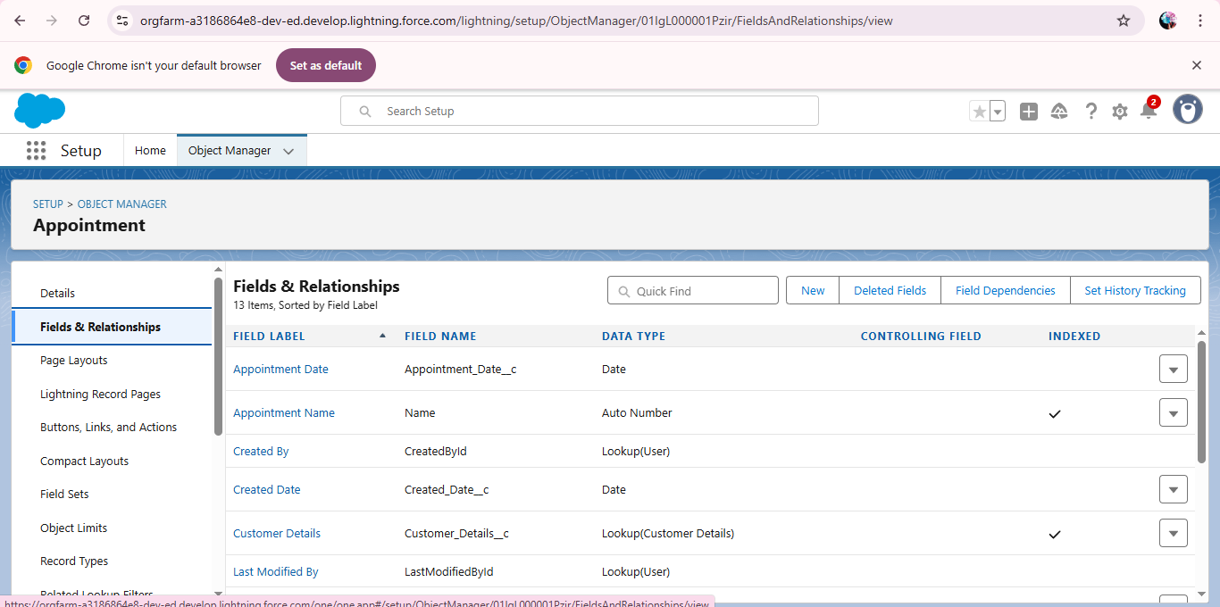

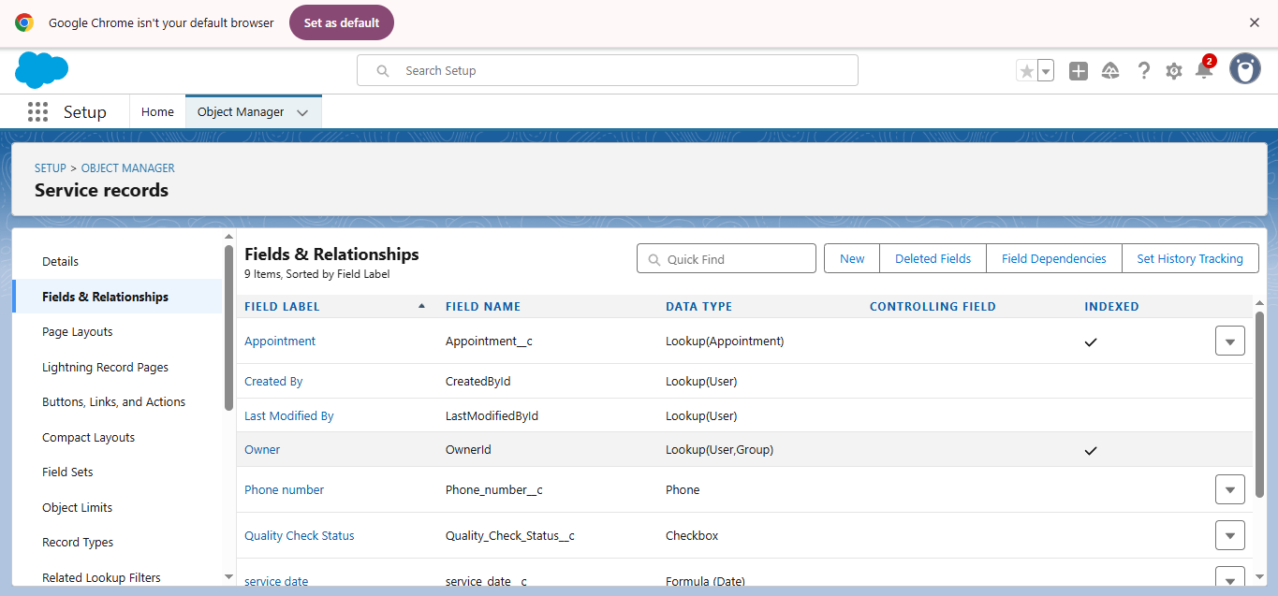

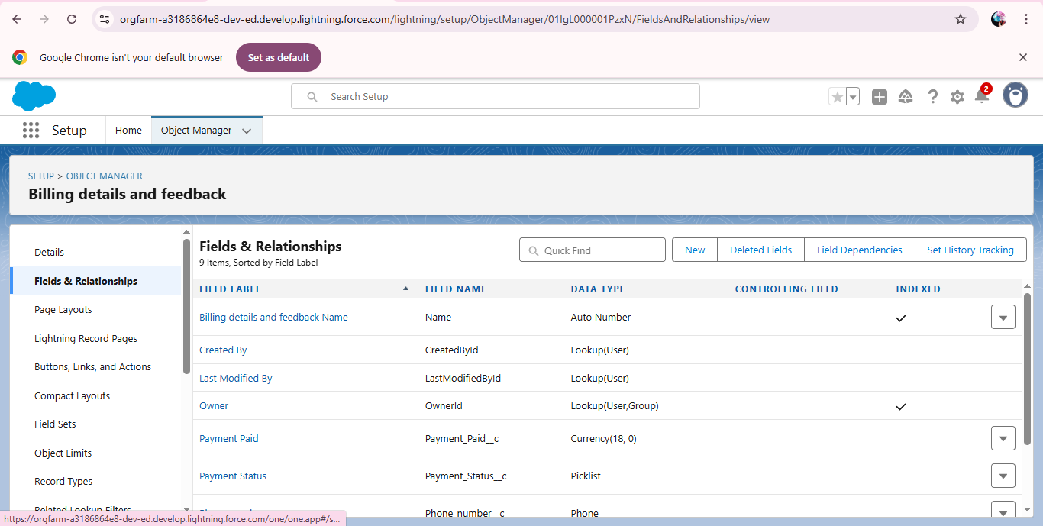

* Validation Rules:
* Validation rules are applied when a user tries to save a record and are used to check if the data meets specified criteria.
* To create a validation rule to an Appointment Object:

### C:\Users\ELCOT\Pictures\Screenshots\15validation.png

### To create a validation rule to an Billing details and feedback Object:

### C:\Users\ELCOT\Pictures\Screenshots\16.pngcreate a matching rule to an Customer details Object:

### https://lh7-us.googleusercontent.com/IM5sqh6h5e3x1MvQwxiSPkNga7nCsta3orY5yTgpnlkf5I_3o1XELSCyQO06a7LmmE-6cM3r2SwxBpOFdicPzjSTQ55mbrqNoHj7V5j9JLXKHi5GGFhnlTTO-sc0dKmHHjRAZqUmhVTt96NAWnje8WYhttps://lh7-us.googleusercontent.com/KQLAy4Tm1wmo2EiwrOk1PrFuHKCJMQDNX6_Nl6GMHy4Aexstct5j9Par5AWL8jsnIFvhU9vCProKT5UjFc2Oqai1KK-svwT6nAKpmNQ9R_qDFvLKqlV4LZISIbGtwnE73oQ6TfrXblyzdXjAAsdnlbYhttps://lh7-us.googleusercontent.com/Of9yqaRctRlYI8cZQFpFLtMxSF327UtqvnfTgoWDrG1gu0tAEnpLZASgBgnI9Shh04kfHX76WoJr9As5Q84Vi6ozLZaqAzVQqUoTQ1ihnSN64aPgoKmVoDRzx2rkxy-84gNplGJ7Rj_7kVPxFzkV-9Ihttps://lh7-us.googleusercontent.com/5HKzgKfI3itvxIVYuM9yDHE06MskY4JjSr0bPA2YjTttFf4KBl74RDYfhUociShK8_s4QweXbZoRSWRV5WgJUOIIOYoAw0yNWObBNSrFlHc1vZ1TjESGh_wx2ZBC7wcSx_R4qZkVwpqiiBIMLMUnFjAcreate a Duplicate rule to an Customer details Object:

### https://lh7-us.googleusercontent.com/BwMs1tUcwlccg3gc908QYEIoFW2aJWrKDQCO-R93lbAuXuqnORX8N2tyjwtoWmsIH9CVYYopibsgWknX_C0xzAlEshHyVSmr2qdnS3mEISZpdtghWVdYBFAUciK7xmbaa8XVIHl7qBtU80EfpLXvWaM

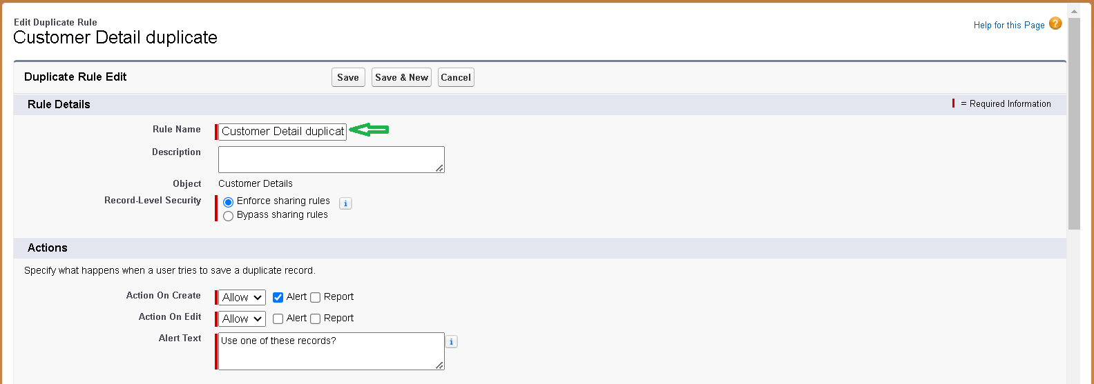

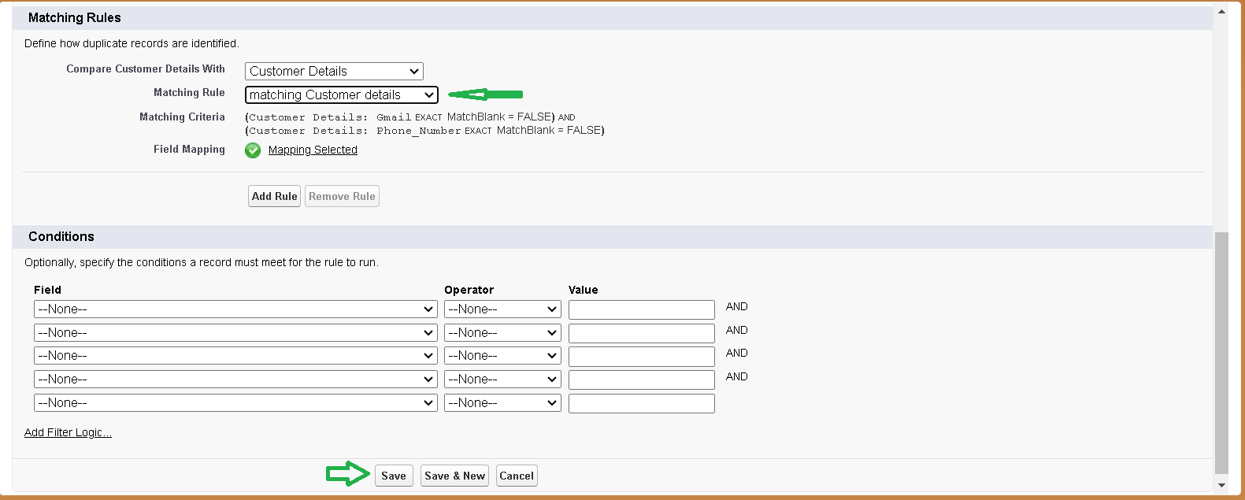

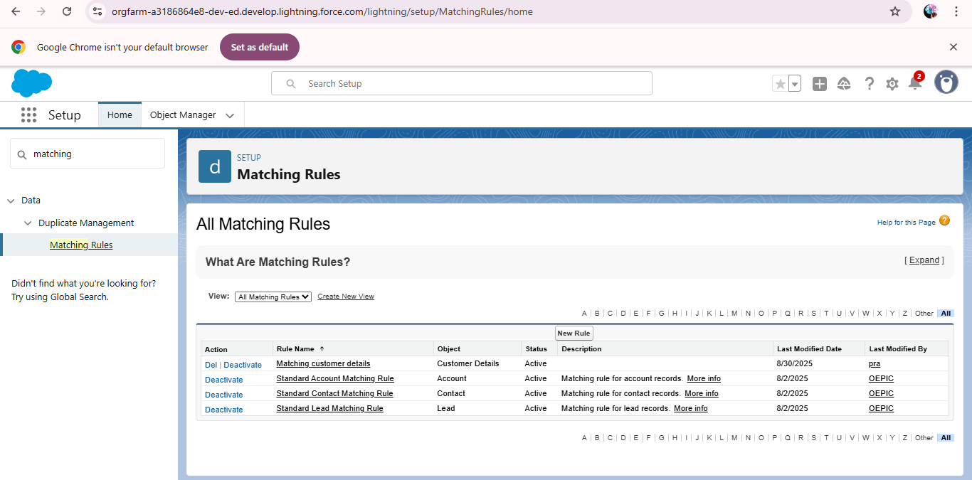

* **To create a new profile:**

Manager Profile

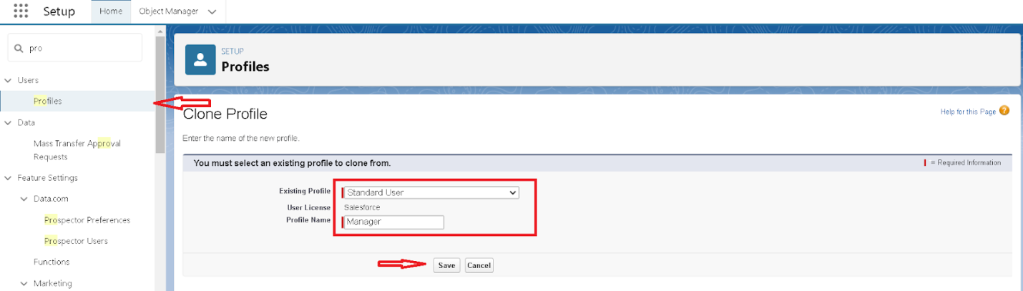

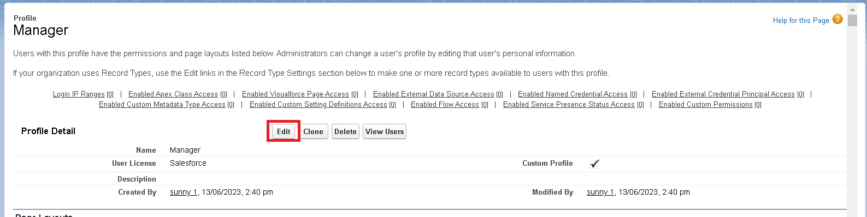

### https://lh7-us.googleusercontent.com/Q-FsatQnsLFtgPbpIDx-f839FK7CPv93HOMJsou3VWmUvIxywtPpu7DSXYhYqtUdywqlNtqHFVchXgMomd2NoYjP3Tb2PWcbyH-yRXUJiTRPJSjItgjZsf8SGUyZQSYdwma-5ORbmshWw6FhMcErDlohttps://lh7-us.googleusercontent.com/FWNhXRqGEFPFQoZ3UN-1aUXAOWEqf8zAUr1BMYI8i0RIhFpjVJjF_8AlIuYSJHxa7lLL2vuz8LIMYxz8T8hhjAoxOuyys7ICvpX2C6Sx-mnO1rOTTsrMzPgytZc4u0JRJQVoaDp89EYRX1K0KL5E63IC:\Users\ELCOT\Pictures\Screenshots\18profile.png Sales person Profile

### https://lh7-us.googleusercontent.com/_AGkkWsOFPLuPISYA4revBbpz1cLEtXkOdL1LZxjObvrQsnGz7H0FUzQpP5nXCmxwDuNKf3XpVB4aHkzzld2IDjtsEWiUut3FNxXoIqIVyRhrkYxu2SLlQe4nloFrpBkvKNUL_Yi4FP85S99CgZVHa4

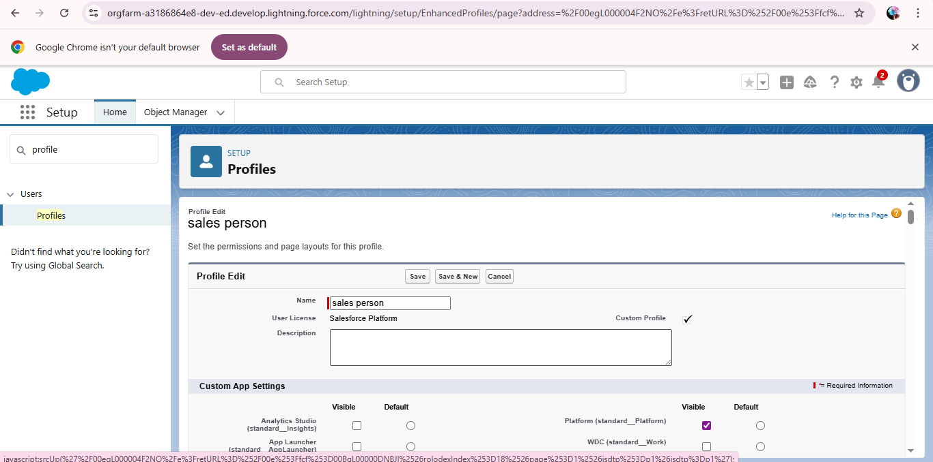

### Creating Manager Role:

### https://lh7-us.googleusercontent.com/W9yO7f2XqKEbzeDODw6WC7_qXPzZbCVy4emf-OYR7YpD-qfprs_5seE08xSa52B4QHN5KN7fidCP94PY_YfJbSyKVE-S6a_n2wv1yiAkSPHBlpMWc8YBxDKLTZhhI-w0lPeWzl27nn52g7cnTxjsijc

### https://lh7-us.googleusercontent.com/k-H4r0O6TfrUWELaFO4Ct0amuDrARwVXrye270LFXqDnXw8wDK1Is6ArTI449ydastFTua1__73dQN6HDIkLY1fJHKkGpsC6ONluCiY7IHlMsTzekA3-DdFHgEccjYqdwBt8PywBG_iub6mOfyKtTgQ

### https://lh7-us.googleusercontent.com/0B9yTgg25qGXZk8mENag4su0juBg-9lMcHG6GpzT1jVT0CVXEVGqpS9QCBBHiVpBD2prFDI00F0IGlTvi8nYswE5_twl7Ow0sDs7ttogXrEG5bddjpWb-XLJb1ibIliNcqH5LNRdmQ5LVp7P2W6W4nA

### Creating another roles

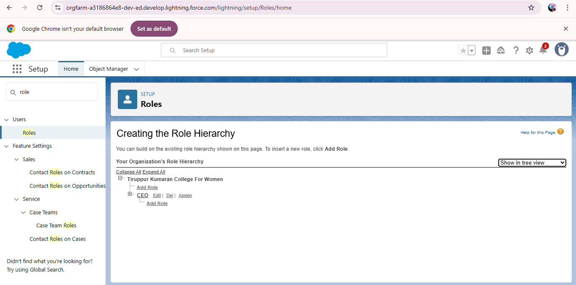

### Create User:

### A user is anyone who logs in to Salesforce. Users are employees at your company, such as sales reps, managers, and IT specialists, who need access to the company's records. Every user in Salesforce has a user account. The user account identifies the user, and the user account settings determine what features and records the user can access.

### https://lh7-us.googleusercontent.com/eqP5tmhjKKKhpGV6F_OH7QRIDRCkloRACe3KtQW_F1g0xbUxk2psrTAP2UYDpc80km53WlBupKcxuuEx46he2Hna2ytWWcKPwXSHsveQxRp9UXjowA6uvBBAC4WRmve3QIIr7AMioVgoQfPH7FTpWc4

### C:\Users\ELCOT\Pictures\Screenshots\21user.png

Created Required users with specified permissions.

### Creating New Public Group:

### https://lh7-us.googleusercontent.com/uIKNpVVCtZhr0bKaBfhWL5Iz0cJDp9Aqh5_BkMqP2QAwHTh9T2iGFVQpuJGBZxyRyO6No6DpaETq33ha7KpkgrKso6F1VWqYxm6XqjDPXaBkCkxLfzAeNSiOuVerSiIs55aRBUFeRoPppO3FLBZ8SVA

### https://lh7-us.googleusercontent.com/R3a6gNlckdNRri3fc7699-h3vJdSPTJ1AgrOTLnF5Fzp1U0YMloN713rQeXAV8BZ9YmQ1bYlZ3Zca8cUlgoUn9xFGgQg0WNquEVRBPpB-02JHhzsCyDBiTbzSQywe8Gr4eFrRTDvyEKSY1-GojSJZM0

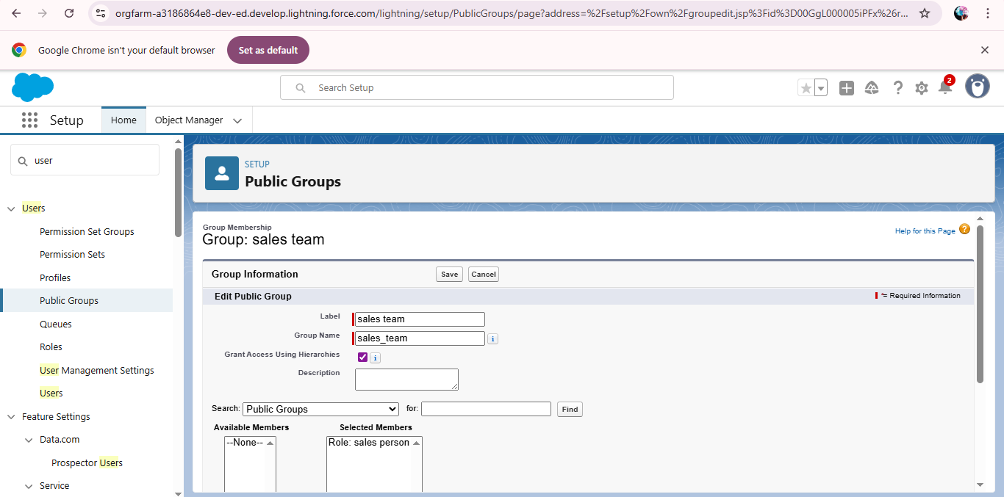

### Creating Sharing settings:

### https://lh7-us.googleusercontent.com/XSyq-Z1tu7RwApuXdhCl8D82zpHOFgKwbputdZ8jZCiTKPm6jyWpeI6o87e0QCUrow33g4LeCnrTBQZQJ8zIxprmNr9wNWE3HKHNxjnUzNOa1YOfCxeYMQJYLweTi_qm03nOD9KhQxLsm_lwMn8rK5k

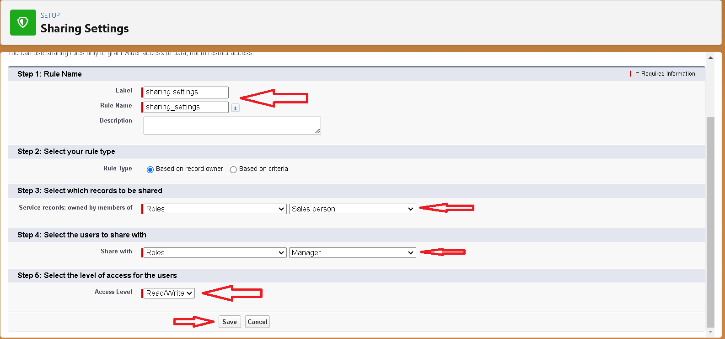

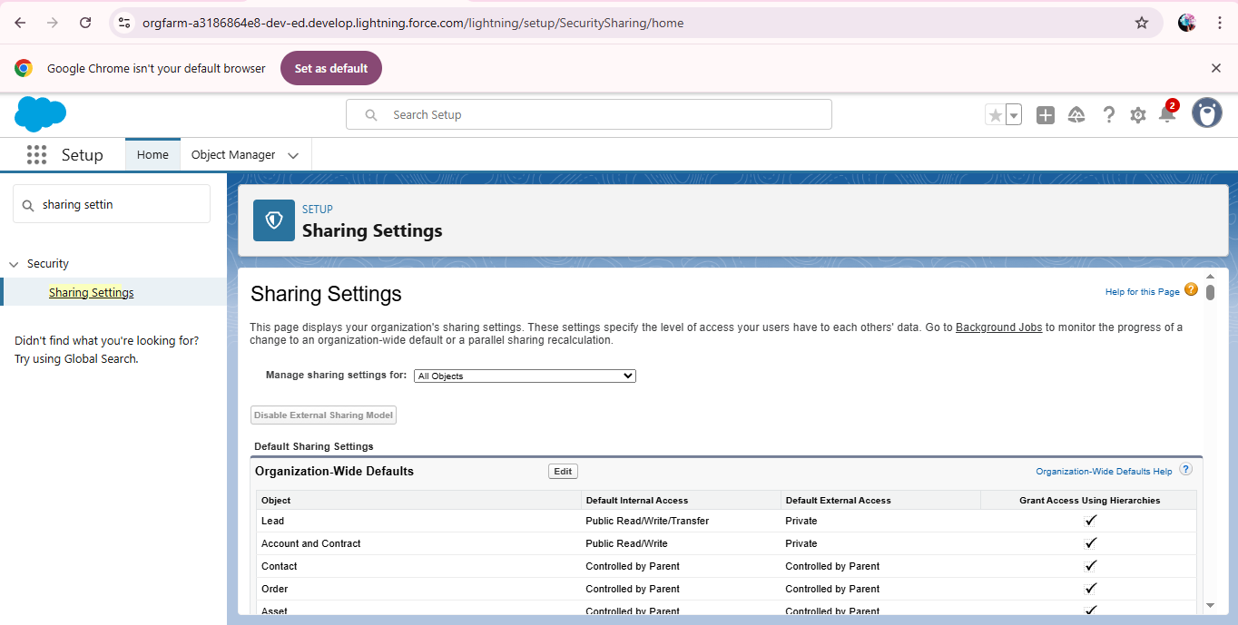

* **Create a Flow**

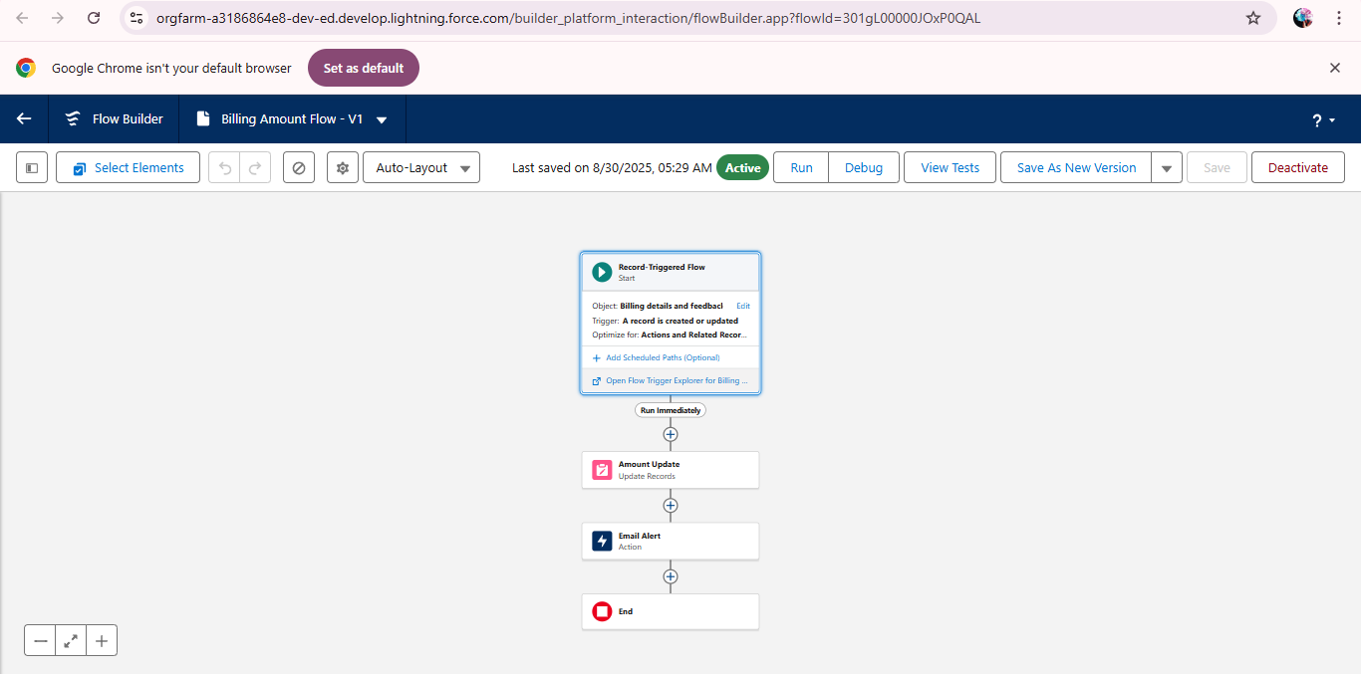

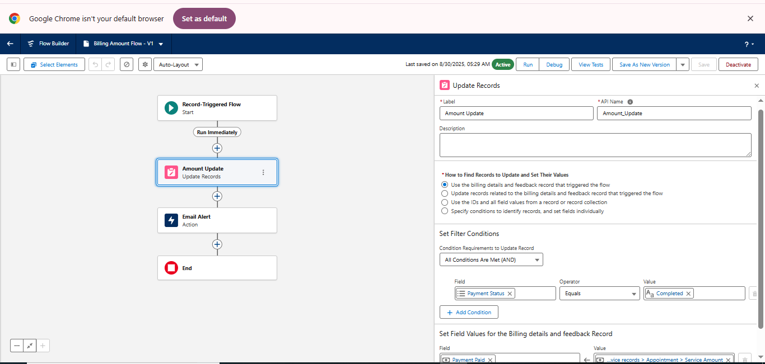

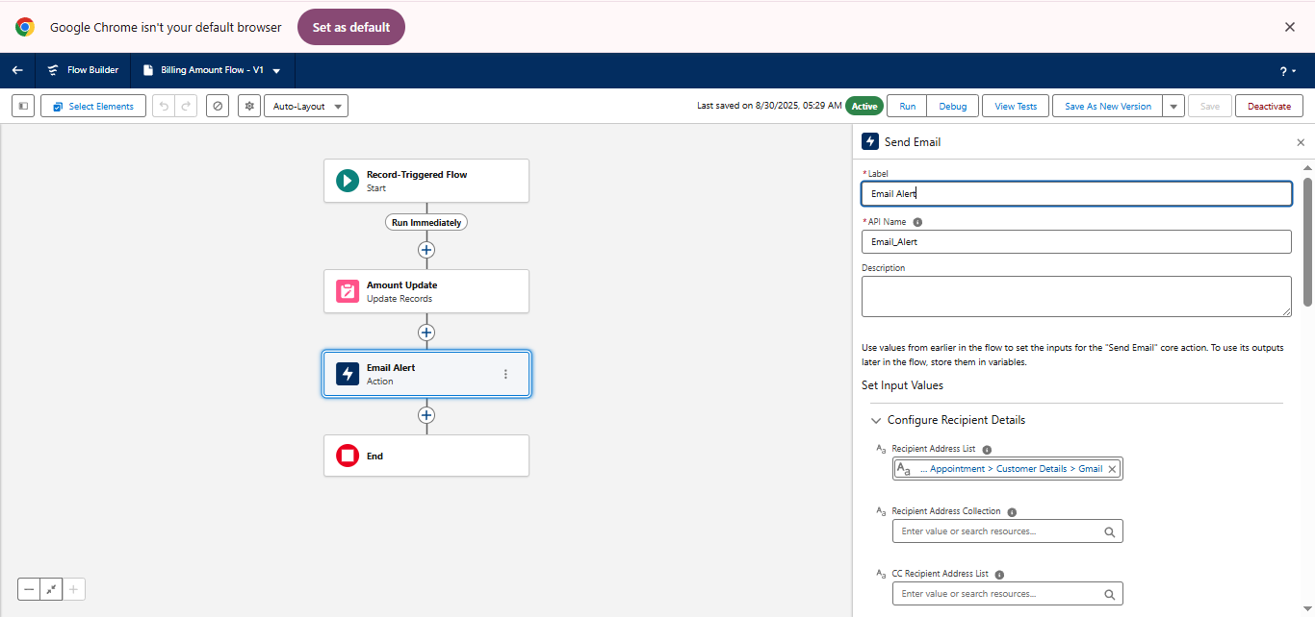

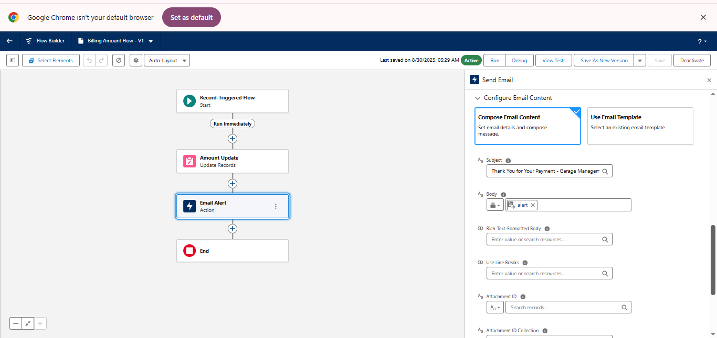

* Created Another Flow

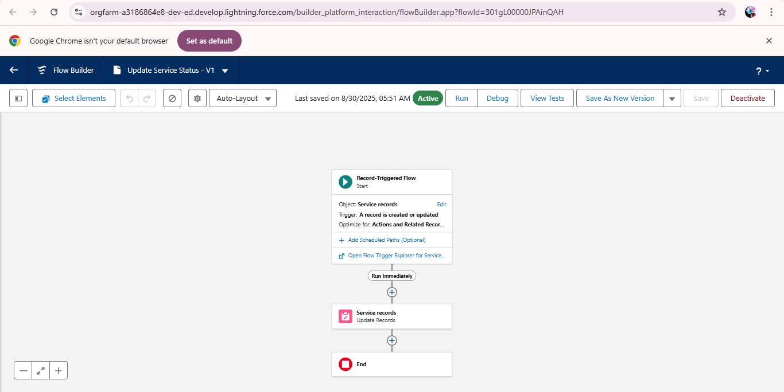

**Apex Trigger**

* Apex can be invoked by using triggers. Apex triggers enable you to perform custom actions

before or after changes to Salesforce records, such as insertions, updates, or deletions.

Amount Distribution Handler

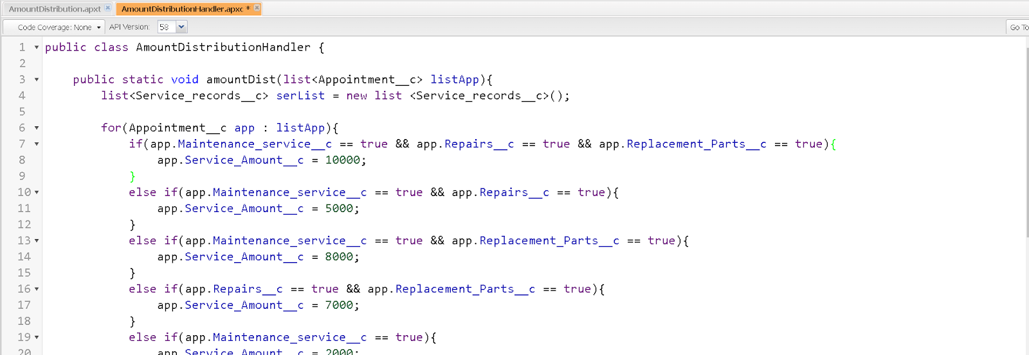

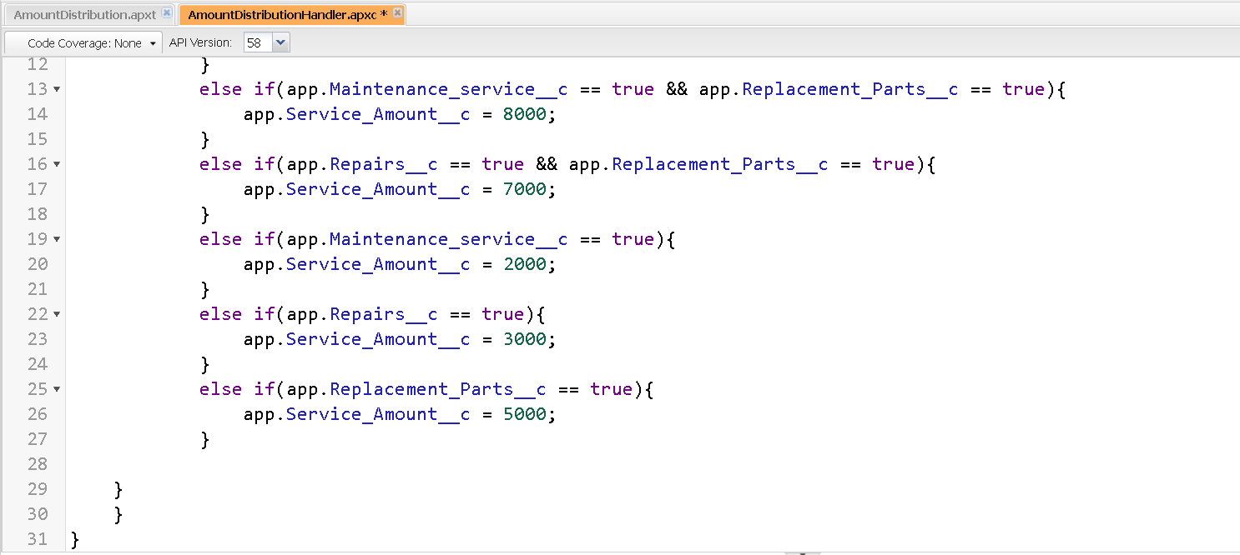

Handler for the Appointment Object

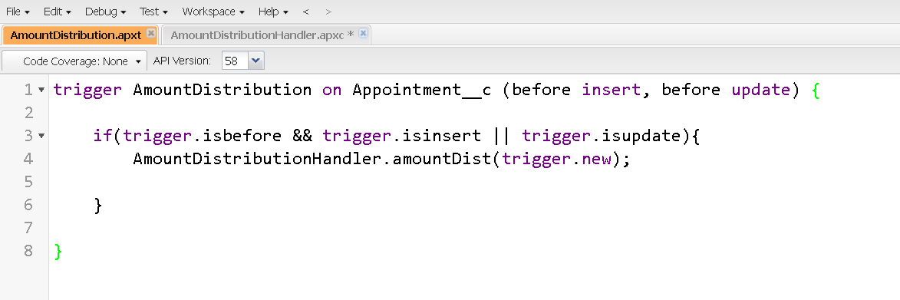

* Reports

Create a Report Folder:

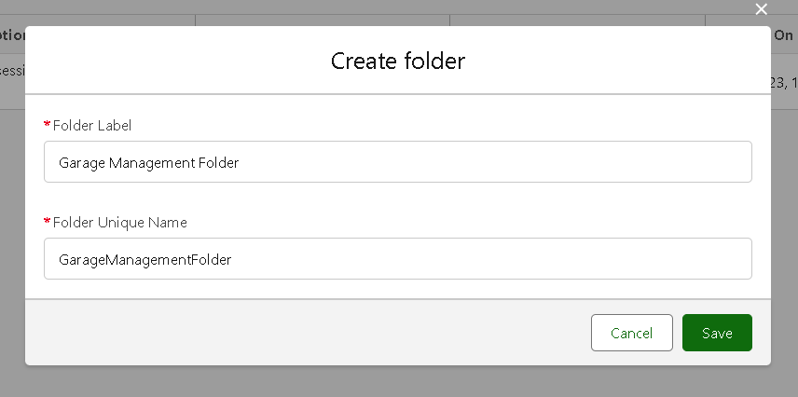

Created Folder

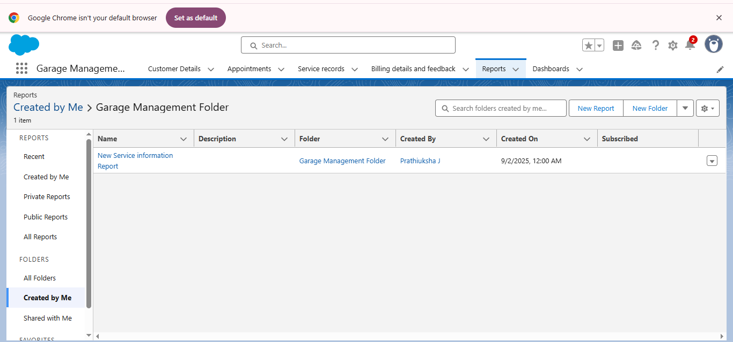

* **Create Dashboard Folder**

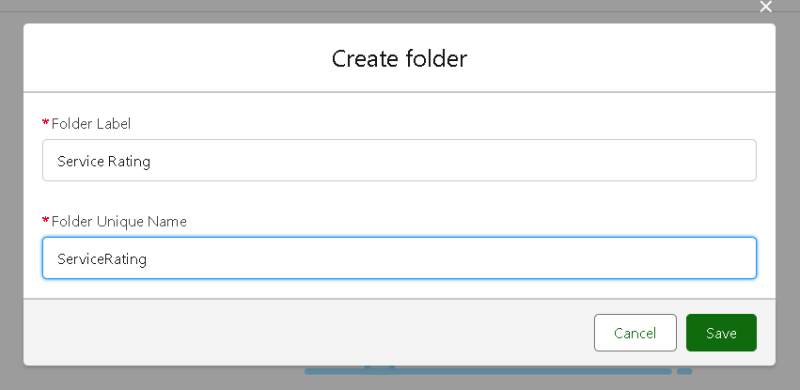

Create Dashboard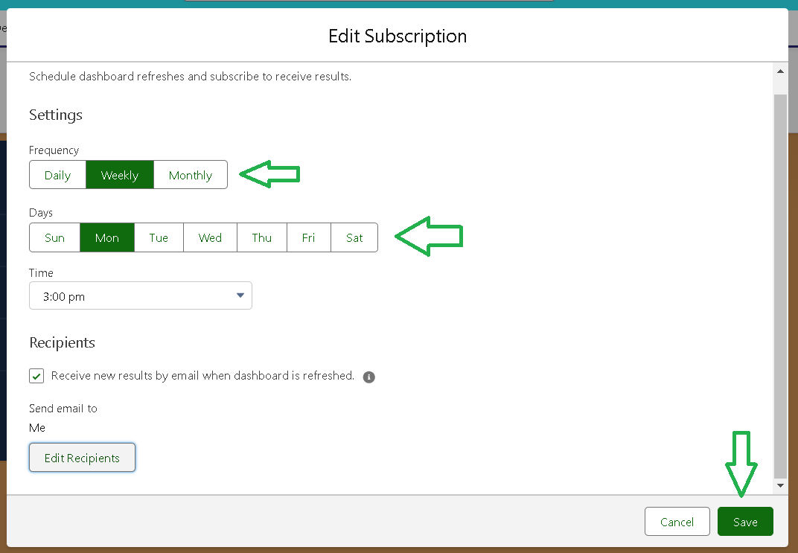

**Results**

**In Garage Management system app we have six fields they are**

* **Customer Details**
* **Appointment**
* **Service Records**
* **Billing Details and feedback**
* **Reports**
* **Dashboard**

**Output Screenshots:**

* **Customer Details: Customer details are Created by entering their names and details and values.**

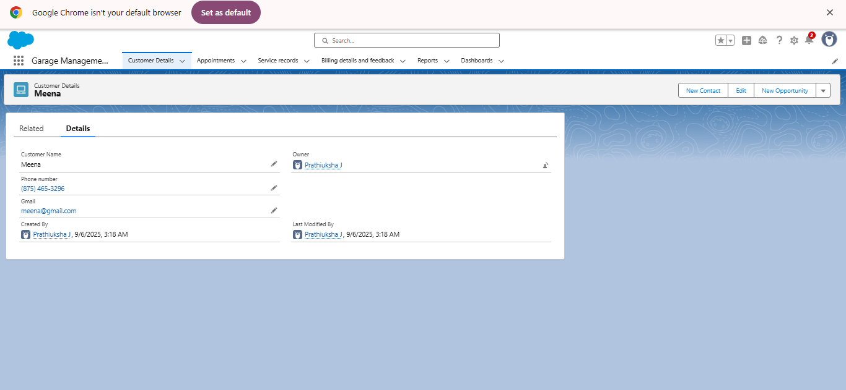

**Created Atleast 10 customer Details**

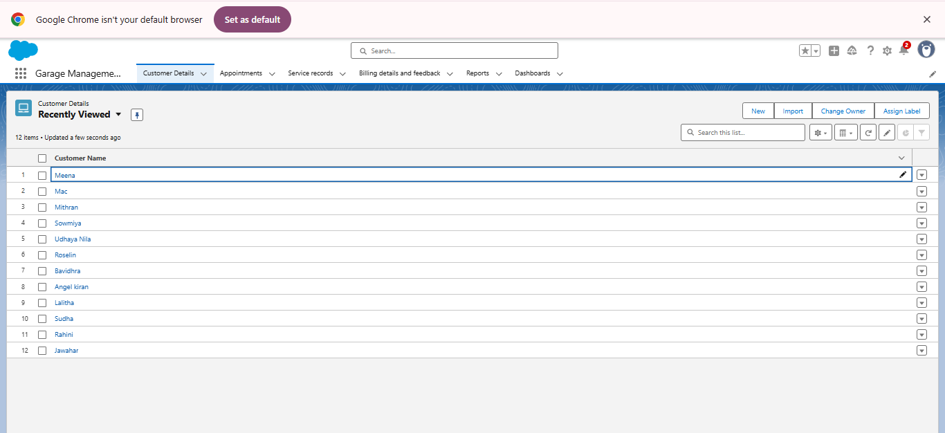

**Created appointment for each customers**

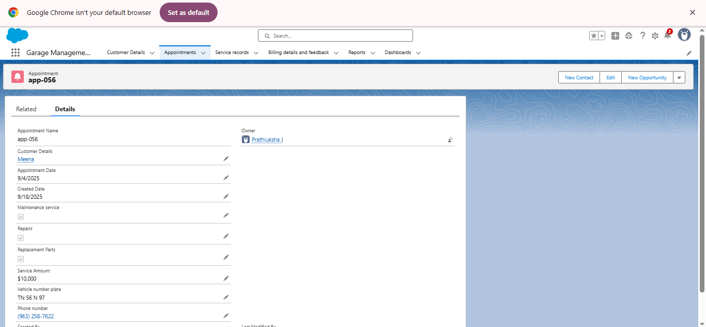

* Service Records

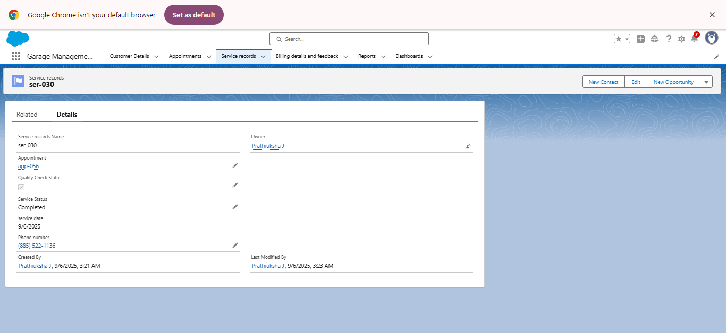

* Billing Details and feedback

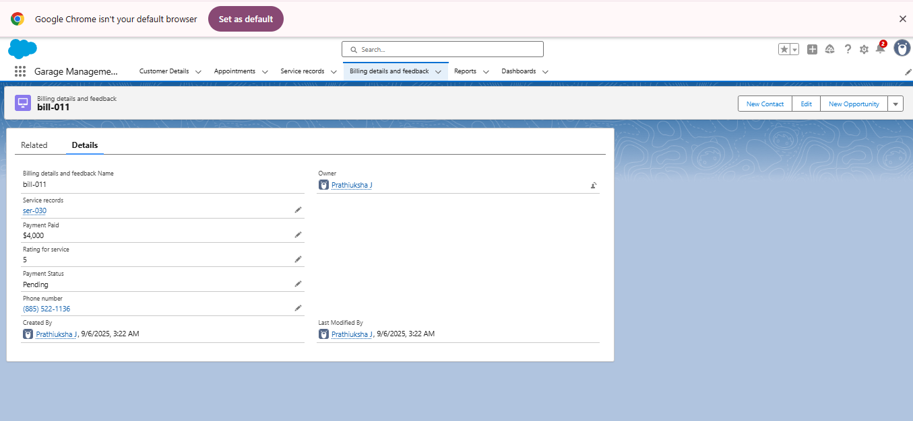

* In reports : we have created a report folder that named as “Garage management system”. We get information about the customer status in garage management system. The reports includes no .of. Bills that is completed the service or not and also include the payment status also. I t shows an Line chart to display the details Completely.



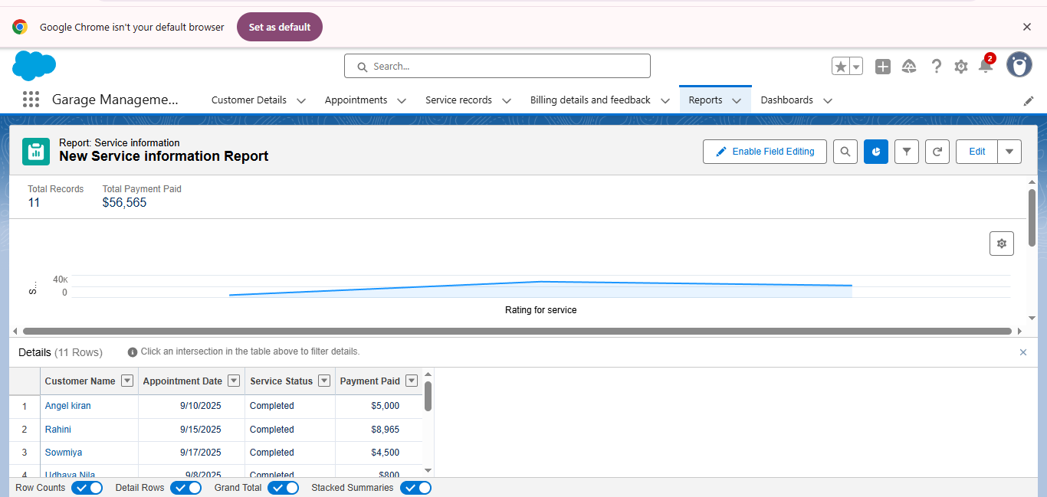

* **Dashboard**

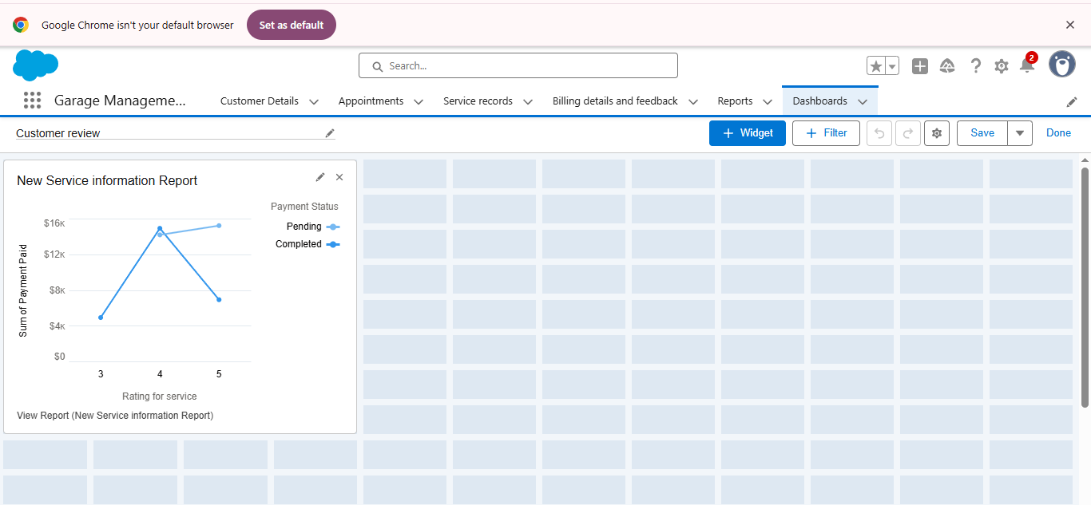

**Advantages and Disadvantages:**

Advantages:

* Improved Efficiency : Automates processes, reducing manual errors and increasing productivity.
* Enhanced Customer Experience : Provides personalized service and real-time updates.
* Better Inventory Management : Tracks parts and materials inventory effectively.
* Data-Driven Insights : Offers reporting and analytics for informed decisions.
* Streamlined Scheduling : Manages appointments and reminders efficiently.

Disadvantages:

* Integration Challenges: Integrating with existing systems can be complex.
* Dependency on Technology: System downtime can disrupt operations.

**CONCLUSION:**

* **Implementing a Garage management system can be a powerful solution for automotive service Centers and garages.**
* **The garage management system aims to transform the garage operations by leveraging technology for improved Efficiency ,customer satisfaction, and data-driven decision making.**
* **A garage management system can driven positive outcomes for garage operation and customer relationships.**

**THANK YOU!**